How To Install the Apache Web Server on Debian 10
ApacheDebian 10
- By Justin Ellingwood, Kathleen Juell, and Hanif Jetha
Published onJuly 19, 2019 104.6k views

Not using Debian 10?
Choose a different version or distribution.

Introduction
The Apache HTTP server is the most widely-used web server in the world. It provides many powerful features including dynamically loadable modules, robust media support, and extensive integration with other popular software.
In this guide, we’ll explain how to install an Apache web server on your Debian 10 server.

Prerequisites
Before you begin this guide, you should have a regular, non-root user with sudo privileges configured on your server. Additionally, you will need to enable a basic firewall to block non-essential ports. You can learn how to configure a regular user account and set up a firewall for your server by following our initial server setup guide for Debian 10.
When you have an account available, log in as your non-root user to begin.

Step 1 — Installing Apache
Apache is available within Debian’s default software repositories, making it possible to install it using conventional package management tools.
Let’s begin by updating the local package index to reflect the latest upstream changes:
sudo apt update

Then, install the apache2 package:
sudo apt install apache2

After confirming the installation, apt will install Apache and all required dependencies.

Step 2 — Adjusting the Firewall
Before testing Apache, it’s necessary to modify the firewall settings to allow outside access to the default web ports. Assuming that you followed the instructions in the prerequisites, you should have a UFW firewall configured to restrict access to your server.
During installation, Apache registers itself with UFW to provide a few application profiles that can be used to enable or disable access to Apache through the firewall.
List the ufw application profiles by typing:
sudo ufw app list

You will see a list of the application profiles:
Output
Available applications:
AIM
Bonjour
CIFS
. . .
WWW
WWW Cache
WWW Full
WWW Secure
. . .
The Apache profiles begin with WWW:
- WWW: This profile opens only port 80 (normal, unencrypted web traffic)
- WWW Cache: This profile opens only port 8080 (sometimes used for caching and web proxies)
- WWW Full: This profile opens both port 80 (normal, unencrypted web traffic) and port 443 (TLS/SSL encrypted traffic)
- WWW Secure: This profile opens only port 443 (TLS/SSL encrypted traffic)
It is recommended that you enable the most restrictive profile that will still allow the traffic you’ve configured. Since we haven’t configured SSL for our server yet in this guide, we will only need to allow traffic on port 80:
sudo ufw allow 'WWW'

You can verify the change by typing:
sudo ufw status

You should see HTTP traffic allowed in the displayed output:
Output
Status: active

To Action From
-- ------ ----
OpenSSH ALLOW Anywhere
WWW ALLOW Anywhere
OpenSSH (v6) ALLOW Anywhere (v6)
WWW (v6) ALLOW Anywhere (v6)
As you can see, the profile has been activated to allow access to the web server.

Step 3 — Checking your Web Server
At the end of the installation process, Debian 10 starts Apache. The web server should already be up and running.
Check with the systemd init system to make sure the service is running by typing:
sudo systemctl status apache2

Output
● apache2.service - The Apache HTTP Server
Loaded: loaded (/lib/systemd/system/apache2.service; enabled; vendor preset: enabled)
Active: active (running) since Fri 2019-07-19 15:33:01 UTC; 4min 13s ago
Docs: https://httpd.apache.org/docs/2.4/

. . .

Jul 19 15:33:01 debssh systemd[1]: Starting The Apache HTTP Server...
Jul 19 15:33:01 debssh apachectl[2791]: AH00558: apache2: Could not reliably determine the server's fully qualified domain name, using 127.0.1.1. Set the 'ServerName' directive global
Jul 19 15:33:01 debssh systemd[1]: Started The Apache HTTP Server.
As you can see from this output, the service appears to have started successfully. However, the best way to test this is to request a page from Apache.
You can access the default Apache landing page to confirm that the software is running properly through your IP address. If you do not know your server’s IP address, you can get it a few different ways from the command line.
Try typing this at your server’s command prompt:
hostname -I

You will get back a few addresses separated by spaces. You can try each in your web browser to see if they work.
An alternative is using the curl tool, which should give you your public IP address as seen from another location on the internet.
First, install curl using apt:
sudo apt install curl

Then, use curl to retrieve icanhazip.com using IPv4:
curl -4 icanhazip.com

When you have your server’s IP address, enter it into your browser’s address bar:
http://your_server_ip
You should see the default Debian 10 Apache web page:
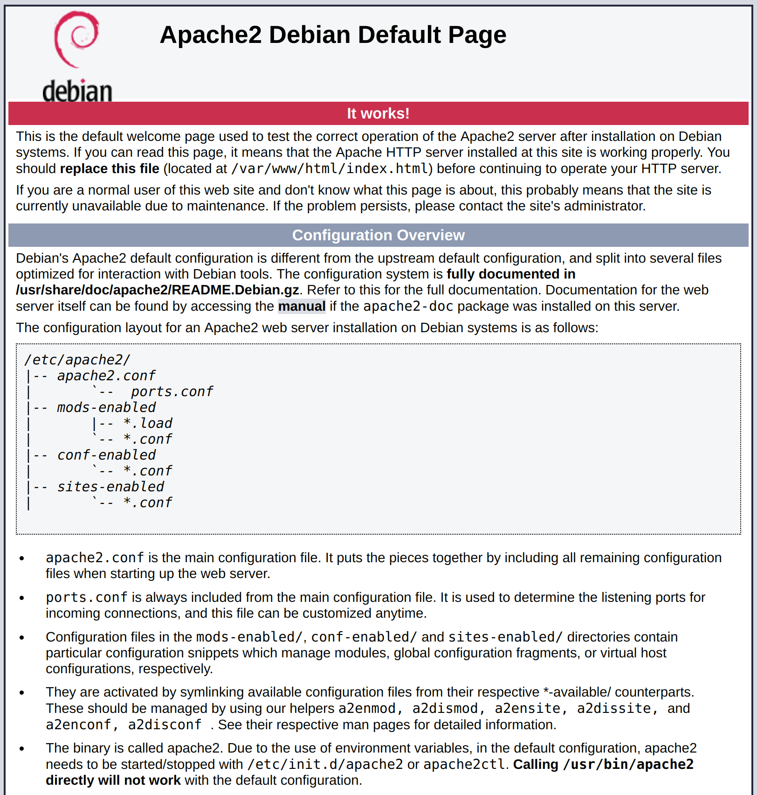
This page indicates that Apache is working correctly. It also includes some basic information about important Apache files and directory locations.

Step 4 — Managing the Apache Process
Now that you have your web server up and running, let’s go over some basic management commands.
To stop your web server, type:
sudo systemctl stop apache2

To start the web server when it is stopped, type:
sudo systemctl start apache2

To stop and then start the service again, type:
sudo systemctl restart apache2

If you are simply making configuration changes, Apache can often reload without dropping connections. To do this, use this command:
sudo systemctl reload apache2

By default, Apache is configured to start automatically when the server boots. If this is not what you want, disable this behavior by typing:
sudo systemctl disable apache2

To re-enable the service to start up at boot, type:
sudo systemctl enable apache2

Apache should now start automatically when the server boots again.

Step 5 — Setting Up Virtual Hosts (Recommended)
When using the Apache web server, you can use virtual hosts (similar to server blocks in Nginx) to encapsulate configuration details and host more than one domain from a single server. In the following commands, replace your_domain with your own domain name. To learn more about setting up a domain name with DigitalOcean, see our Introduction to DigitalOcean DNS.
Apache on Debian 10 has one server block enabled by default that is configured to serve documents from the /var/www/html directory. While this works well for a single site, it can become unwieldy if you are hosting multiple sites. Instead of modifying /var/www/html, let’s create a directory structure within /var/www for our your_domain site, leaving /var/www/html in place as the default directory to be served if a client request doesn’t match any other sites.
Create the directory for your_domain as follows, using the -p flag to create any necessary parent directories:
sudo mkdir -p /var/www/your_domain
Next, assign ownership of the directory with the $USER environmental variable:
sudo chown -R $USER:$USER /var/www/your_domain

The permissions of your web roots should be correct if you haven’t modified your unmask value, but you can make sure by typing:
sudo chmod -R 755 /var/www/your_domain

Next, create a sample index.html page using nano or your favorite editor:
nano /var/www/your_domain/index.html

Inside, add the following sample HTML:
/var/www/your_domain/index.html
<html>
<head>
<title>Welcome to your_domain!</title>
</head>
<body>
<h1>Success! The your_domain virtual host is working!</h1>
</body>
</html>

Save and close the file when you are finished.
In order for Apache to serve this content, it’s necessary to create a virtual host file with the correct directives. Instead of modifying the default configuration file located at /etc/apache2/sites-available/000-default.conf directly, let’s make a new one at /etc/apache2/sites-available/your_domain.conf:
sudo nano /etc/apache2/sites-available/your_domain.conf

Paste in the following configuration block, which is similar to the default, but updated for our new directory and domain name:
/etc/apache2/sites-available/your_domain.conf
<VirtualHost *:80>
ServerAdmin admin@your_email_domain
ServerName your_domain
ServerAlias www.your_domain
DocumentRoot /var/www/your_domain
ErrorLog ${APACHE_LOG_DIR}/error.log
CustomLog ${APACHE_LOG_DIR}/access.log combined
</VirtualHost>

Notice that we’ve updated the DocumentRoot to our new directory and ServerAdmin to an email that the your_domain site administrator can access. We’ve also added two directives: ServerName, which establishes the base domain that should match for this virtual host definition, and ServerAlias, which defines further names that should match as if they were the base name.
Save and close the file when you are finished.
Let’s enable the file with the a2ensite tool:
sudo a2ensite your_domain.conf

Disable the default site defined in 000-default.conf:
sudo a2dissite 000-default.conf

Next, let’s test for configuration errors:
sudo apache2ctl configtest

You should see the following output:
Output
AH00558: apache2: Could not reliably determine the server's fully qualified domain name, using 127.0.1.1. Set the 'ServerName' directive globally to suppress this message
Syntax OK
Restart Apache to implement your changes:
sudo systemctl restart apache2

Apache should now be serving your domain name. You can test this by navigating to http://your_domain, where you should see something like this:

Step 6 – Getting Familiar with Important Apache Files and Directories
Now that you know how to manage the Apache service itself, you should take a few minutes to familiarize yourself with a few important directories and files.

Content
- /var/www/html: The actual web content, which by default only consists of the default Apache page you saw earlier, is served out of the /var/www/html directory. This can be changed by altering Apache configuration files.

Server Configuration
- /etc/apache2: The Apache configuration directory. All of the Apache configuration files reside here.
- /etc/apache2/apache2.conf: The main Apache configuration file. This can be modified to make changes to the Apache global configuration. This file is responsible for loading many of the other files in the configuration directory.
- /etc/apache2/ports.conf: This file specifies the ports that Apache will listen on. By default, Apache listens on port 80 and additionally listens on port 443 when a module providing SSL capabilities is enabled.
- /etc/apache2/sites-available/: The directory where per-site virtual hosts can be stored. Apache will not use the configuration files found in this directory unless they are linked to the sites-enabled directory. Typically, all server block configuration is done in this directory, and then enabled by linking to the other directory with the a2ensite command.
- /etc/apache2/sites-enabled/: The directory where enabled per-site virtual hosts are stored. Typically, these are created by linking to configuration files found in the sites-available directory with the a2ensite. Apache reads the configuration files and links found in this directory when it starts or reloads to compile a complete configuration.
- /etc/apache2/conf-available/, /etc/apache2/conf-enabled/: These directories have the same relationship as the sites-available and sites-enabled directories, but are used to store configuration fragments that do not belong in a virtual host. Files in the conf-available directory can be enabled with the a2enconf command and disabled with the a2disconf command.
- /etc/apache2/mods-available/, /etc/apache2/mods-enabled/: These directories contain the available and enabled modules, respectively. Files in ending in .load contain fragments to load specific modules, while files ending in .conf contain the configuration for those modules. Modules can be enabled and disabled using the a2enmod and a2dismod command.

Server Logs
- /var/log/apache2/access.log: By default, every request to your web server is recorded in this log file unless Apache is configured to do otherwise.
- /var/log/apache2/error.log: By default, all errors are recorded in this file. The LogLevel directive in the Apache configuration specifies how much detail the error logs will contain.

Conclusion
Now that you have your web server installed, you have many options for the type of content you can serve and the technologies you can use to create a richer experience.
If you’d like to build out a more complete application stack, you can look at this article on how to configure a LAMP stack on Debian 10.
https://www.digitalocean.com/community/tutorials/how-to-install-the-apache-web-server-on-debian-10

How to Install Apache Web Server on Debian 10 Linux
Posted
•
3 min read

Apache HTTP server is one of the most popular web servers in the world. It is an open-source and cross-platform HTTP server that powers a large percentage of the Internet’s websites. Apache provides many powerful features that can be extended through additional modules.
In this tutorial, we’ll explain how to install Apache on Debian 10, Buster.

Prerequisites
Before starting with the tutorial, make sure you are logged in as a user with sudo privileges .

Installing Apache
Apache packages are available in the default Debian repositories.
The installation is pretty straightforward. Update the package index and install the Apache web server with the following commands:

sudo apt updatesudo apt install apache2
That’s it, Apache is installed and automatically started. To check the status type:

sudo systemctl status apache2
● apache2.service - The Apache HTTP Server
Loaded: loaded (/lib/systemd/system/apache2.service; enabled; vendor preset:
Active: active (running) since Sat 2019-07-27 13:55:49 PDT; 21s ago
...

Adjust the Firewall
UFW users can open HTTP (80) and HTTPS (443) ports by enabling the ‘Nginx Full’ profile:
sudo ufw allow 'Apache Full'
If you are using nftables to filter connections to your system, open the necessary ports by issuing the following command:
nft add rule inet filter input tcp dport {80, 443} ct state new,established counter accept

Verifying Apache Installation
To verify that Apache works correctly, open your browser , type your server IP address or domain name http://YOUR_IP_OR_DOMAIN/, and you will see the default Apache welcome page as shown below:

The page contains basic information about Apache configuration files, helper scripts, and directory locations.

Apache Configuration File’s Structure and Best Practices
- In Debian based systems Apache configuration files are located in the /etc/apache2 directory.
- The main Apache configuration file is /etc/apache2/apache2.conf.
- The ports that Apache will listen to are specified in the /etc/apache2/ports.conf file.
- Apache Virtual Hosts files are located in the /etc/apache2/sites-available directory. The configuration files found in this directory are not used by Apache unless they are linked to the /etc/apache2/sites-enabled directory.
- You can activate a virtual host directive by creating a symlink using the a2ensite command from the configuration files found in the sites-available directory to the sites-enabled directory. To deactivate a virtual host use the a2dissite command.
- It is highly recommended to follow the standard naming convention, for example, if your domain name is mydomain.com then the domain configuration file should be named /etc/apache2/sites-available/mydomain.com.conf
- Configuration files that are used for loading various Apache modules are located in the /etc/apache2/mods-available directory. Configurations in the mods-available directory can be enabled by creating a symlink to the /etc/apache2/mods-enable directory using the a2enconf command and disabled with the a2disconf command.
- Files containing global configuration fragments are stored in the /etc/apache2/conf-available directory. Files in the conf-available directory can be enabled by creating a symlink to the /etc/apache2/conf-enabled using the a2enconf command and disabled with the a2disconf command.
- Apache log files (access.log and error.log) are located in the /var/log/apache directory. It is recommended to use different access and error log files for each virtual host.
- You can set your domain document root directory to any location you want. The most common locations for webroot include:
  - /home/<user_name>/<site_name>
  - /var/www/<site_name>
  - /var/www/html/<site_name>
  - /opt/<site_name>

Conclusion
Installing Apache on Debian is a matter of running a single command.
You can now start deploying your applications and use Apache as a web or proxy server.
If you have any questions or feedback, feel free to leave a comment.

https://linuxize.com/post/how-to-install-apache-on-debian-10/

